### Name: ____________________________________

| Exam 2 – Spring 2020 VERSION C | |
| --- | --- |
| Course Information: Phys 2B | Instructor Name: John R. Walkup |

***d*** = ***v***o*t* + (1/2)***a****t*2 ***v*** = ***v***o + ***a****t*  ***F***net = *m****a*** ***F***g = *m***g** *V* = *kQ/r  **V* = *Ed V =IR P = I*2*R*

*WC = –*PE *WNC =* E *Wnet =* 😐E *W* = *Fd*cos     😐  *mv*2 *F*Q = *kQ*1*Q*2*/r*2 PE = *kQ*1*Q*2*/r*

*k* = 9 X 109 in SI *e =* 1.6 X 10-19 *C* 1 mC = 10-3 C 1 mC = 10-6 C 1 nC = 10-9 C

*If none of the numerical responses matches your solution, choose the closet numerical value.*

#### Multiple-Choice Questions

1. The charge density on the surface of an isolated, charged conductor is highest where the surface is
2. Sharpest
3. Flattest
4. 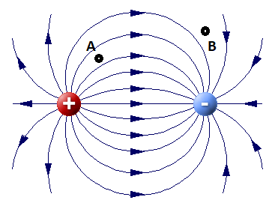Softest
5. Hardest
6. An electric field (arrows) and corresponding equipotential lines are shown in the figure. Which of the following is true?
7. The potential at Point A is higher than at Point B.
8. The potential at Point A is lower than at Point B.
9. The potential at Points A and B cannot be determined because no charge exists at Points A and B.
10. The potential at Point A is the same as at Point B and is nonzero.
11. 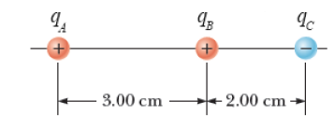The figure below shows three small, charged beads, all lying along the horizontal axis. Bead A, at left, has a 6.70 nC charge. Bead B has a 1.45 nC charge and is 3.00 cm to the right of A. Bead C has a charge of -2.60 nC and is 2.00 cm to the right of B. Find the magnitude of the net electric force on Bead A.
12. 3.44 X 10-5 N
13. 2.12 X 10-5 N
14. 3.89 X 10-5 N
15. 4.18 X 10-5 N
16. 4.57 X 10-5 N
17. 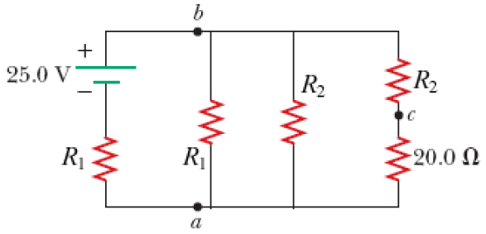Consider the circuit shown in the figure, where *R*1 = 10.5 Ω and R2 = 4.50 Ω. Find the potential difference between points *a* and *b*.*
18. 3.75 V.
19. 5.25 V
20. 6.50 V.
21. 4.25 V.
22. 7.75 V.
23. 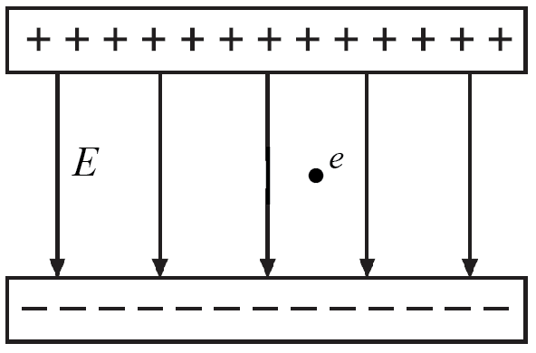A negatively-charged electron is placed between the two charged plates shown in the figure. Once released, what will happen to its potential, kinetic, and total energies over time?
24. All three energies will drop.
25. All three energies will increase.
26. Its potential energy will drop, its kinetic energy will increase, and its total energy will remain constant.
27. Its potential energy will increase, its kinetic energy will drop, and its total energy will drop.
28. 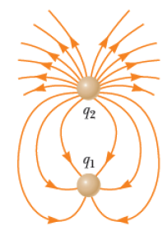Its potential energy will drop, but its kinetic and total energies will remain constant.
29. The figure shows an electric field between two charges. Which of the following is correct? (|*q*| refers to the magnitude of *q*. For example, |–3| = 3.)
30. Charge *q*1 is negative, *q*2 is positive, and | *q*1| > | *q*2|.
31. Charge *q*1 is negative, *q*2 is positive, and | *q*1| < | *q*2|.
32. Charge *q*1 is positive, *q*2 is negative, and | *q*1| > | *q*2|.
33. Charge *q*1 is positive, *q*2 is negative, and | *q*1| < | *q*2|.
34. Both charges are positive but | *q*1| < | *q*2|.
35. What happens when a charged insulator is placed near an uncharged metallic object?
36. They attract each other.
37. They repel each other.
38. They may attract or repel each other depending on whether the charge on the insulator is positive or negative.
39. They exert no electrostatic force on each other.
40. The charged insulator always spontaneously discharges.
41. A proton is released from rest in a uniform electric field of magnitude 352 N/C. Find the distance it travels in 1.94 μs (i.e., 1.94 X 10-6 s). The mass of a proton is 1.673 X 10-27 kg.*
42. 3.72 cm
43. 1.19 cm
44. 6.35 cm
45. 4.88 cm
46. 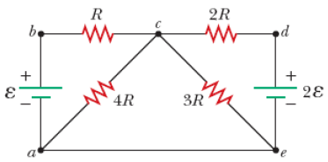2.54 cm
47. Taking *R* = 3000 Ω and ℰ = 240 V in the figure shown, determine the current in the horizontal wire between *a* and *e*.*
48. 15.9 mA
49. 12.1 mA
50. 5.1 mA
51. 8.8 mA
52. 17.3 mA
53. A conductor is placed inside a non-constant electric field.
54. The electric field is 0 everywhere inside the conductor. Outside the conductor the electric field is distorted by the conductor.
55. The electric field inside the conductor will eventually become constant throughout the conductor but not necessarily 0, depending on how much charge is on the conductor surface.
56. The presence of the conductor zeroes out the electric field both inside and outside the conductor.
57. The electric field outside the conductor is unaffected, but vanishes inside the conductor.
58. The conductor has no effect at all because it is not an insulator.
59. The A uniform electric field of magnitude 386 N/C pointing in the positive x-direction acts on an electron, which is initially at rest. The electron moves 3.10 cm toward the right. What is the change in potential energy associated with the electron? (Note that *e* = 1.6 X 10-19 C.)
60. + 3.34 X 10-17 J
61. – 2.56 X 10-17 J
62. – 2.67 X 10-16 J
63. – 1.92 X 10-18 J
64. + 1.23 X 10-16 J
65. The potential difference across a resistor in a particular electric circuit is 210 V. The current through the resistor is 17.0 A. What is its power dissipation?
66. 3,570 W
67. 6,801 W
68. 4,681 W
69. 7,915 W
70. 4,092 W

#### Free response

1. 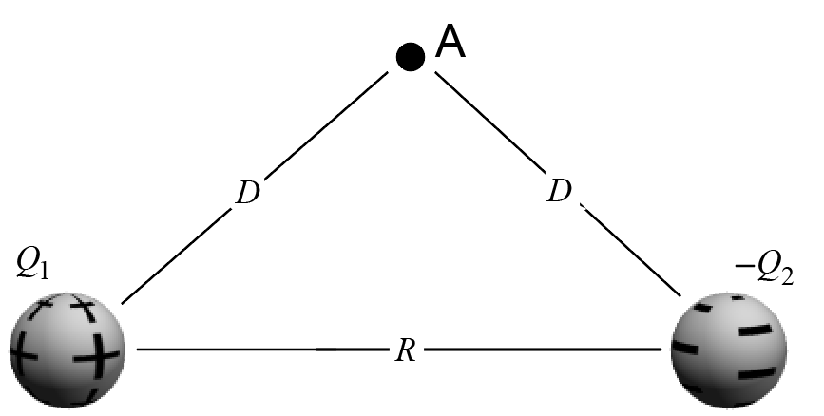Pictured are two point charges. Here, *Q*1 = +5 mC and *Q*2 = – 3 mC. Also, *R* = 6 m and *D* = 17 m. Assume the triangle has interior angles of 45o, 45o, and 90o. Find…
2. The electric field strength and direction at Point A.
3. The voltage between Points A and B.
4. Suppose we placed a charge *q* = +4 mC at Point A and move it at constant velocity to Point B by applying a force *F*A on the charge. According to the work-energy theorems, how much work is done by the Coulombic force (i.e., the charge force) from both charges during this movement?
5. How much work is done by the applied force *F*A?
6. What happens to the potential energy, kinetic energy, and total energy of the charge as it moves from Point A to Point B? (Provide numerical answers, not just “it rises…”)

NOTE: The magnitudes of the two charges are NOT the same! One is +4 mC and the other is –2 mC. Therefore, the electric field will not simply point directly to the right as it did on the practice test.

1. Picture is an electrical circuit with batteries shown as circles. The resistors marked V1, V2, and V3 have the values 3 W, 5 W, and 7 W, respectively.
2. Derive and circle the equations you would use to solve for the currents passing through each resistor.

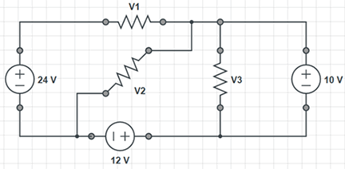

1. Solve the system of equations for the values of the current passing through each resistor. (1 point of extra credit)